操作系统实验报告
Lab 2: Threads and Synchronization

一、实验目的
实现Nachos的同步机制：锁和条件变量，并利用这些同步机制实现几个基础工具类。

二、实验要求

1、Implementing Mutexes and Condition Variables
互斥体和条件变量的公共接口在synch.h中定义，其中包括关于原语语义的重要注释。条件变量接口在某些方面很笨拙，但请接受synch.h定义的接口。您的第一个任务是在synch.h中为这些类定义私有数据，并在synch.cc中实现接口。查看SynchList以了解如何使用互斥体和条件变量的同步原语。您需要在synch.h和synch.cc文件的两个不同版本中编写这些同步原语的两个不同实现。通过（最坏的情况下）移动这些文件并重新编译nachos，您应该能够从一个版本切换到另一个版本。
以下是更详细的具体步骤和要求：
（1）使用睡眠/唤醒原语（Thread::sleep 和 Scheduler::ReadyToRun原语）实现锁定和条件变量。有必要在战略点暂时禁用中断，以消除不适时中断或非自愿上下文切换的可能性。特别是，Thread::Sleep要求您在调用中断之前禁用中断。但是，在没有必要禁用中断时，您可能会因保持中断处于禁用状态而失去分数。禁用中断是一种钝器，除非必要，否则应避免使用。
（2）使用信号量作为唯一的同步原语来实现锁和条件变量。这一次没有必要（或允许）在代码中禁用中断：信号量原语根据实现信号量抽象的需要禁用中断，您现在可以使用它作为同步的充分“立足点”。警告：这部分作业看似简单，但实际上是最微妙和困难的。特别是，条件变量的解决方案应确保信号不会影响后续等待。
（3）从实验 1中修改DLList类，使其使用同步原语，以确保即使多个线程使用该列表，该列表仍能持续更新。您可能希望查看SynchList类（在threads/SynchList.h和threads/SynchList.cc中）以了解如何执行此操作。为了演示代码的工作原理，如实验1所示，创建一个类似于文件threadtest.cc的驱动程序文件，该文件调用DLList类的同步版本。对threads/main.cc进行更改，以便执行nachos命令会导致执行新驱动程序文件中的函数，而不是文件ThreadTest.cc中的函数ThreadTest。使用DLList的同步版本测试锁和条件变量的两个版本。

2、Implementing a Multithreaded Table
实现一个线程安全的表类，它存储由[0..size-1]范围内的整数索引的非类型化对象指针的集合。您可以在以后的实验中使用Table来实现进程、线程、内存页帧、打开文件等的内部操作系统表。Table具有以下方法，这些方法在课程目录（子目录aux）中提供的头文件Table.h中定义：
Table(int size) ——创建一个表以容纳最多大小的条目。
int Alloc (void* object) ——为对象分配一个表槽，返回已分配项的索引。如果没有可用的表插槽，则返回错误（-1）。
void* Get (int index) ——从索引处的表槽中检索对象，如果未分配，则返回NULL。
void Release (int index) ——在索引处释放表槽。

3、Implementing a Bounded Buffer
这是一个称为有界生产者/消费者的经典同步问题。基于*/aux/BoundedBuffer.h中的定义，实现一个线程安全的BoundedBuffer类。
BoundedBuffer(int maxsize) ——创建一个最多容纳maxsize字节的有界缓冲区。
void Read(void*data，int size) ——从缓冲区读取大小字节，直到有足够的字节完全满足请求为止。从地址数据开始将字节复制到内存中。
void Write (void* data, int size) ——将大小字节写入缓冲区，直到有足够的空间完全满足请求为止。从地址数据开始从内存复制字节。
将在Unix实验室中使用基本的缓冲区（IPC）管道来实现ED5通信机制。基本思想是管道或BoundedBuffer将数据从生产者线程（调用写入）传递到消费者线程（调用读取）。使用者通过写入接收放在缓冲区中的字节，其顺序与生产者写入的字节顺序相同。如果生产者生成数据太快（即缓冲区溢出超过maxsize字节），则写入会使生产者处于休眠状态，直到消费者能够从缓冲区捕获并读取一些数据，从而释放空间。如果使用者读取数据太快（即缓冲区清空），则读取会使使用者进入睡眠状态，直到生产者能够赶上并生成更多字节。请注意，对于哪些线程调用Read和哪些线程调用Write没有限制。您的实现不应该假设只有两个线程使用它，或者调用线程充当生产者和消费者的固定角色。如果给定的BoundedBuffer被多个线程使用，那么您应该注意保持读写请求的原子性。也就是说，由给定写入操作写入的数据永远不应该与来自其他写入操作的数据交叉发送到读取器。即使写入程序和/或读取器由于缓冲区填满或耗尽而被迫阻塞，该不变量也应保持不变。

4、(EXTRA CREDIT) Implementing a Priority Scheduler
跟踪threads/thread.cc、threads/scheduler.h和threads/scheduler.cc中的代码，以了解默认nachos调度程序如何选择要运行的下一个线程（无论是线程显式生成CPU时，还是当时间片完成时）。要实现基于优先级的非抢占式调度程序，请修改线程调度程序以始终返回优先级最高的线程。您可能希望将scheduler.h和scheduler.cc复制到具有不同名称的文件中，并修改这些副本而不是原始副本。您还需要为线程创建一个新的构造函数，以获取另一个参数——线程的优先级。请保持旧的构造函数不变，因为您需要它来实现向后兼容性。你可以假设有一个小的，固定数量的优先级-对于这个任务，你只需要两个。通过使用调度器实现运行有界缓冲区实现来测试调度器实现。更改生产者线程和消费者线程的相对优先级会对输出产生影响吗？例如，当一个生产者的优先级高于另一个生产者时，两个生产者和一个消费者会发生什么情况？如果两个生产者的优先级相同，但消费者的优先级较高，该怎么办？要获得所需的行为，请确保在生产者和消费者代码中调用了Thread::Yield（仅针对实验的这一部分）。

5、其他说明
锁和条件变量的实现应使用第2.2节（请参阅跟踪和调试Nachos程序）中所述的断言检查，以强制执行正确行为所需的任何使用约束。例如，对信号和等待的每次调用都会传递一个相关的互斥锁；如果给定的条件变量与多个互斥体一起使用，会出现什么问题？如果持锁人再次尝试获取持有的锁，会发生什么情况？如果线程试图释放它不持有的锁，该怎么办？这些断言检查是此分配的价值点，它们将在以后的分配中为您省去麻烦。
您还需要考虑其他使用问题。例如，如果调用方试图删除一个互斥对象或条件变量对象，而该对象上有阻塞的线程，那么您的实现应该怎么做？您应该能够解释为什么您的实现是正确的（例如，如果我们将收益率放在X行和Y行之间会发生什么），并在各种使用场景下对其行为（公平性、饥饿等）进行评论。
警告：Nachos条件变量接口很难看，因为它在每次调用Wait或Signal时都会传递相关的互斥体，而不是在条件变量构造函数中只绑定一次互斥体。这意味着您必须添加代码来记住第一次调用时要等待或发出信号的互斥量，以便在后续调用中验证正确的用法。但请不要搞错：每个条件变量只与一个互斥体一起使用，如synch.h中所述。确保你理解为什么这是如此重要。
警告：信号量的定义不能保证在V中唤醒的线程在另一个线程调用P之前有机会运行。特别是，信号量的Nachos实现不能保证这种行为。也就是说，如果计数从零变为一，V会增加计数并唤醒阻塞的线程，但唤醒的线程有责任在P中唤醒后再次减少计数。如果另一个线程先调用P，那么它可能会使用“为”被唤醒线程“准备”的计数，这将导致被唤醒线程返回睡眠状态并等待另一个V。
注意：对于调试，可以使用-s调试标志。但是，当前没有带s 的DEBUG标志的调试语句，因此需要向代码中添加一些。参见第2.2节（参见Nachos程序的跟踪和调试）。

三、实验流程

1、修改synch.h文件，使用睡眠/唤醒原语实现锁和条件变量，并将名称改为synch-sleep.h后另存一份。

#ifndef SYNCH_H
#define SYNCH_H
#include "copyright.h"
#include "thread.h"
#include "list.h"
// The following class defines a "semaphore" whose value is a non-negative
// integer. The semaphore has only two operations P() and V():
//
// P() -- waits until value > 0, then decrement
//
// V() -- increment, waking up a thread waiting in P() if necessary
//
// Note that the interface does *not* allow a thread to read the value of
// the semaphore directly -- even if you did read the value, the
// only thing you would know is what the value used to be. You don't
// know what the value is now, because by the time you get the value
// into a register, a context switch might have occurred,
// and some other thread might have called P or V, so the true value might
// now be different.
class Semaphore {
public:
Semaphore(char* debugName, int initialValue); // set initial value
~Semaphore(); // de-allocate semaphore
char* getName() { return name;} // debugging assist
void P(); // these are the only operations on a semaphore
void V(); // they are both *atomic*
private:
char* name; // useful for debugging
int value; // semaphore value, always >= 0
List *queue; // threads waiting in P() for the value to be > 0
};
// The following class defines a "lock". A lock can be BUSY or FREE.
// There are only two operations allowed on a lock:
//
// Acquire -- wait until the lock is FREE, then set it to BUSY
//
// Release -- set lock to be FREE, waking up a thread waiting
// in Acquire if necessary
//
// In addition, by convention, only the thread that acquired the lock
// may release it. As with semaphores, you can't read the lock value
// (because the value might change immediately after you read it).
class Lock {
public:
Lock(char* debugName); // initialize lock to be FREE
~Lock(); // deallocate lock
char* getName() { return name; } // debugging assist
void Acquire(); // these are the only operations on a lock
void Release(); // they are both *atomic*
bool isHeldByCurrentThread(); // true if the current thread
// holds this lock. Useful for
// checking in Release, and in
// Condition variable ops below.
private:
char* name; // for debugging
// plus some other stuff you'll need to define
int value; // lock value, FREE or BUSY
List *queue; // wait queue
Thread *current; // mark the owner of this lock
};
// lock value
#define FREE 0
#define BUSY 1
// The following class defines a "condition variable". A condition
// variable does not have a value, but threads may be queued, waiting
// on the variable. These are only operations on a condition variable:
//
// Wait() -- release the lock, relinquish the CPU until signaled,
// then re-acquire the lock
//
// Signal() -- wake up a thread, if there are any waiting on
// the condition
//
// Broadcast() -- wake up all threads waiting on the condition
//
// All operations on a condition variable must be made while
// the current thread has acquired a lock. Indeed, all accesses
// to a given condition variable must be protected by the same lock.
// In other words, mutual exclusion must be enforced among threads calling
// the condition variable operations.
//
// In Nachos, condition variables are assumed to obey *Mesa*-style
// semantics. When a Signal or Broadcast wakes up another thread,
// it simply puts the thread on the ready list, and it is the responsibility
// of the woken thread to re-acquire the lock (this re-acquire is
// taken care of within Wait()). By contrast, some define condition
// variables according to *Hoare*-style semantics -- where the signalling
// thread gives up control over the lock and the CPU to the woken thread,
// which runs immediately and gives back control over the lock to the
// signaller when the woken thread leaves the critical section.
//
// The consequence of using Mesa-style semantics is that some other thread
// can acquire the lock, and change data structures, before the woken
// thread gets a chance to run.
class Condition {
public:
Condition(char* debugName); // initialize condition to
// "no one waiting"
~Condition(); // deallocate the condition
char* getName() { return (name); }
void Wait(Lock *conditionLock); // these are the 3 operations on
// condition variables; releasing the
// lock and going to sleep are
// *atomic* in Wait()
void Signal(Lock *conditionLock); // conditionLock must be held by
void Broadcast(Lock *conditionLock);// the currentThread for all of
// these operations
private:
char* name;
// plus some other stuff you'll need to define
List *queue; // wait queue
};
#endif // SYNCH_SLEEP_H

2、修改synch.cc文件，使用睡眠/唤醒原语实现锁和条件变量，并将名称改为synch-sleep.cc后另存一份。
#include "copyright.h"
#include "synch.h"
#include "system.h"
//----------------------------------------------------------------------
// Semaphore::Semaphore
// Initialize a semaphore, so that it can be used for synchronization.
//
// "debugName" is an arbitrary name, useful for debugging.
// "initialValue" is the initial value of the semaphore.
//----------------------------------------------------------------------
Semaphore::Semaphore(char* debugName, int initialValue)
{
name = debugName;
value = initialValue;
queue = new List;
}
//----------------------------------------------------------------------
// Semaphore::Semaphore
// De-allocate semaphore, when no longer needed. Assume no one
// is still waiting on the semaphore!
//----------------------------------------------------------------------
Semaphore::~Semaphore()
{
delete queue;
}
//----------------------------------------------------------------------
// Semaphore::P
// Wait until semaphore value > 0, then decrement. Checking the
// value and decrementing must be done atomically, so we
// need to disable interrupts before checking the value.
//
// Note that Thread::Sleep assumes that interrupts are disabled
// when it is called.
//----------------------------------------------------------------------
void
Semaphore::P()
{
IntStatus oldLevel = interrupt->SetLevel(IntOff); // disable interrupts
while (value == 0) { // semaphore not available
queue->Append((void *)currentThread); // so go to sleep
currentThread->Sleep();
}
value--; // semaphore available,
// consume its value
(void) interrupt->SetLevel(oldLevel); // re-enable interrupts
}
//----------------------------------------------------------------------
// Semaphore::V
// Increment semaphore value, waking up a waiter if necessary.
// As with P(), this operation must be atomic, so we need to disable
// interrupts. Scheduler::ReadyToRun() assumes that threads
// are disabled when it is called.
//----------------------------------------------------------------------
void
Semaphore::V()
{
Thread *thread;
IntStatus oldLevel = interrupt->SetLevel(IntOff);
thread = (Thread *)queue->Remove();
if (thread != NULL) // make thread ready, consuming the V immediately
scheduler->ReadyToRun(thread);
value++;
(void) interrupt->SetLevel(oldLevel);
}
// Dummy functions -- so we can compile our later assignments
// Note -- without a correct implementation of Condition::Wait(),
// the test case in the network assignment won't work!
//----------------------------------------------------------------------
// Lock::Lock
// Initialize lock to be FREE.
//----------------------------------------------------------------------
Lock::Lock(char* debugName)
{
name = debugName;
value = FREE;
queue = new List;
}
//----------------------------------------------------------------------
// Lock::~Lock
// Deallocate lock
//----------------------------------------------------------------------
Lock::~Lock()
{
delete queue;
}
//----------------------------------------------------------------------
// Lock::Acquire
// Acquire a lock when lock is free, or put into wait queue.
//----------------------------------------------------------------------
void Lock::Acquire()
{
ASSERT (isHeldByCurrentThread() == FALSE); // forbide re-allocating lock
IntStatus oldLevel = interrupt->SetLevel(IntOff); // disable interrupts;
while (value == BUSY) // lock is busy, waiting
{
queue->Append((void *)currentThread); // put thread on wait queue
currentThread->Sleep(); // go to sleep
}
value = BUSY; // when lock is free, grab it
current = currentThread;
(void) interrupt->SetLevel(oldLevel); // enable interrupts
}
//----------------------------------------------------------------------
// Lock::Release
// Release a lock.
//----------------------------------------------------------------------
void Lock::Release()
{
Thread *thread;
ASSERT (isHeldByCurrentThread() == TRUE); // if not held by current thread, abort
IntStatus oldLevel = interrupt->SetLevel(IntOff); // disable interrupts
thread = (Thread *)queue->Remove(); // take thread off wait queue
if (thread != NULL) // if anyone on wait queue
scheduler->ReadyToRun(thread); // place on ready queue
value = FREE; // release lock
current = NULL;
(void) interrupt->SetLevel(oldLevel); // enable interrupts
}
//----------------------------------------------------------------------
// Lock::isHeldByCurrentThread
// Return true if the current thread holds this lock, false otherwise.
//----------------------------------------------------------------------
bool Lock::isHeldByCurrentThread()
{
if (current == currentThread)
return TRUE;
else
return FALSE;
}
//----------------------------------------------------------------------
// Condition::Condition
// Initinalize condition variable.
//----------------------------------------------------------------------
Condition::Condition(char* debugName)
{
name = debugName;
queue = new List;
}
//----------------------------------------------------------------------
// Condition::Condition
// Delete condition variable.
//----------------------------------------------------------------------
Condition::~Condition()
{
delete queue;
}
//----------------------------------------------------------------------
// Condition::Wait
// Atomically release lock and go to sleep. Re-acquire lock later,
// before returning.
//----------------------------------------------------------------------
void Condition::Wait(Lock* conditionLock)
{
ASSERT (conditionLock->isHeldByCurrentThread() == TRUE);
IntStatus oldLevel = interrupt->SetLevel(IntOff); // disable interrupts
queue->Append((void *)currentThread); // add this thread to queue
conditionLock->Release(); // release lock
currentThread->Sleep(); // go to sleep
conditionLock->Acquire(); // re-acquire lock
(void) interrupt->SetLevel(oldLevel); // enable interrupts
}
//----------------------------------------------------------------------
// Condition::Signal
// Wake up one waiter, if any.
//----------------------------------------------------------------------
void Condition::Signal(Lock* conditionLock)
{
Thread *thread;
// ASSERT (conditionLock->isHeldByCurrentThread() == TRUE);
IntStatus oldLevel = interrupt->SetLevel(IntOff); // disable interrupts
thread = (Thread *)queue->Remove(); // take thread off wait queue
if (thread != NULL) // if anyone on wait queue
scheduler->ReadyToRun(thread); // wake up thread, place on ready queue
(void) interrupt->SetLevel(oldLevel); // enable interrupts
}
//----------------------------------------------------------------------
// Condition::Broadcast
// Wake up all waiters.
//----------------------------------------------------------------------
void Condition::Broadcast(Lock* conditionLock)
{
Thread *thread;
// ASSERT (conditionLock->isHeldByCurrentThread() == TRUE);
IntStatus oldLevel = interrupt->SetLevel(IntOff); // disable interrupts
thread = (Thread *)queue->Remove(); // remove from wait queue
while (thread != NULL)
{
scheduler->ReadyToRun(thread); // wake up
thread = (Thread *)queue->Remove(); // continue removing
}
(void) interrupt->SetLevel(oldLevel); // enable interrupts
}

3、修改synch.h文件，使用信号量实现锁和条件变量，并将名称改为synch-sem.h后另存一份。

#ifndef SYNCH_H
#define SYNCH_H
#include "copyright.h"
#include "thread.h"
#include "list.h"
// The following class defines a "semaphore" whose value is a non-negative
// integer. The semaphore has only two operations P() and V():
//
// P() -- waits until value > 0, then decrement
//
// V() -- increment, waking up a thread waiting in P() if necessary
//
// Note that the interface does *not* allow a thread to read the value of
// the semaphore directly -- even if you did read the value, the
// only thing you would know is what the value used to be. You don't
// know what the value is now, because by the time you get the value
// into a register, a context switch might have occurred,
// and some other thread might have called P or V, so the true value might
// now be different.
class Semaphore {
public:
Semaphore(char* debugName, int initialValue); // set initial value
~Semaphore(); // de-allocate semaphore
char* getName() { return name;} // debugging assist
void P(); // these are the only operations on a semaphore
void V(); // they are both *atomic*
private:
char* name; // useful for debugging
int value; // semaphore value, always >= 0
List *queue; // threads waiting in P() for the value to be > 0
};
// The following class defines a "lock". A lock can be BUSY or FREE.
// There are only two operations allowed on a lock:
//
// Acquire -- wait until the lock is FREE, then set it to BUSY
//
// Release -- set lock to be FREE, waking up a thread waiting
// in Acquire if necessary
//
// In addition, by convention, only the thread that acquired the lock
// may release it. As with semaphores, you can't read the lock value
// (because the value might change immediately after you read it).
class Lock {
public:
Lock(char* debugName); // initialize lock to be FREE
~Lock(); // deallocate lock
char* getName() { return name; } // debugging assist
void Acquire(); // these are the only operations on a lock
void Release(); // they are both *atomic*
bool isHeldByCurrentThread(); // true if the current thread
// holds this lock. Useful for
// checking in Release, and in
// Condition variable ops below.
private:
char* name; // for debugging
// plus some other stuff you'll need to define
Semaphore *sem; // semaphore for lock
Thread *current; // note down the current thread
};
// The following class defines a "condition variable". A condition
// variable does not have a value, but threads may be queued, waiting
// on the variable. These are only operations on a condition variable:
//
// Wait() -- release the lock, relinquish the CPU until signaled,
// then re-acquire the lock
//
// Signal() -- wake up a thread, if there are any waiting on
// the condition
//
// Broadcast() -- wake up all threads waiting on the condition
//
// All operations on a condition variable must be made while
// the current thread has acquired a lock. Indeed, all accesses
// to a given condition variable must be protected by the same lock.
// In other words, mutual exclusion must be enforced among threads calling
// the condition variable operations.
//
// In Nachos, condition variables are assumed to obey *Mesa*-style
// semantics. When a Signal or Broadcast wakes up another thread,
// it simply puts the thread on the ready list, and it is the responsibility
// of the woken thread to re-acquire the lock (this re-acquire is
// taken care of within Wait()). By contrast, some define condition
// variables according to *Hoare*-style semantics -- where the signalling
// thread gives up control over the lock and the CPU to the woken thread,
// which runs immediately and gives back control over the lock to the
// signaller when the woken thread leaves the critical section.
//
// The consequence of using Mesa-style semantics is that some other thread
// can acquire the lock, and change data structures, before the woken
// thread gets a chance to run.
class Condition {
public:
Condition(char* debugName); // initialize condition to
// "no one waiting"
~Condition(); // deallocate the condition
char* getName() { return (name); }
void Wait(Lock *conditionLock); // these are the 3 operations on
// condition variables; releasing the
// lock and going to sleep are
// *atomic* in Wait()
void Signal(Lock *conditionLock); // conditionLock must be held by
void Broadcast(Lock *conditionLock);// the currentThread for all of
// these operations
private:
char* name;
// plus some other stuff you'll need to define
Semaphore *s, *x, *h; // use names used in Implementing Condition
// Variables with Semaphores, A. D. Birrell, 2003
int waiters;
};
#endif // SYNCH_SEM_H

4、修改synch.cc文件，使用信号量实现锁和条件变量，并将名称改为synch-sem.cc后另存一份。

#include "copyright.h"
#include "synch.h"
#include "system.h"
//----------------------------------------------------------------------
// Semaphore::Semaphore
// Initialize a semaphore, so that it can be used for synchronization.
//
// "debugName" is an arbitrary name, useful for debugging.
// "initialValue" is the initial value of the semaphore.
//----------------------------------------------------------------------
Semaphore::Semaphore(char* debugName, int initialValue)
{
name = debugName;
value = initialValue;
queue = new List;
}
//----------------------------------------------------------------------
// Semaphore::Semaphore
// De-allocate semaphore, when no longer needed. Assume no one
// is still waiting on the semaphore!
//----------------------------------------------------------------------
Semaphore::~Semaphore()
{
delete queue;
}
//----------------------------------------------------------------------
// Semaphore::P
// Wait until semaphore value > 0, then decrement. Checking the
// value and decrementing must be done atomically, so we
// need to disable interrupts before checking the value.
//
// Note that Thread::Sleep assumes that interrupts are disabled
// when it is called.
//----------------------------------------------------------------------
void
Semaphore::P()
{
IntStatus oldLevel = interrupt->SetLevel(IntOff); // disable interrupts
while (value == 0) { // semaphore not available
queue->Append((void *)currentThread); // so go to sleep
currentThread->Sleep();
}
value--; // semaphore available,
// consume its value
(void) interrupt->SetLevel(oldLevel); // re-enable interrupts
}
//----------------------------------------------------------------------
// Semaphore::V
// Increment semaphore value, waking up a waiter if necessary.
// As with P(), this operation must be atomic, so we need to disable
// interrupts. Scheduler::ReadyToRun() assumes that threads
// are disabled when it is called.
//----------------------------------------------------------------------
void
Semaphore::V()
{
Thread *thread;
IntStatus oldLevel = interrupt->SetLevel(IntOff);
thread = (Thread *)queue->Remove();
if (thread != NULL) // make thread ready, consuming the V immediately
scheduler->ReadyToRun(thread);
value++;
(void) interrupt->SetLevel(oldLevel);
}
// Dummy functions -- so we can compile our later assignments
// Note -- without a correct implementation of Condition::Wait(),
// the test case in the network assignment won't work!
//----------------------------------------------------------------------
// Lock::Lock
// Initialize lock.
//----------------------------------------------------------------------
Lock::Lock(char* debugName)
{
name = debugName;
sem = new Semaphore("lock semaphore", 1); // initial semaphore value is 1
current = NULL;
}
//----------------------------------------------------------------------
// Lock::~Lock
// Deallocate lock.
//----------------------------------------------------------------------
Lock::~Lock()
{
delete sem;
}
//----------------------------------------------------------------------
// Lock::Acquire
// Acquire a lock, just do P()'s op, since binary semaphore quite looks
// like a lock.
//----------------------------------------------------------------------
void Lock::Acquire()
{
ASSERT (isHeldByCurrentThread() == FALSE);
sem->P();
current = currentThread;
}
//----------------------------------------------------------------------
// Lock::Release
// Release a lock, do V()'s op.
//----------------------------------------------------------------------
void Lock::Release()
{
ASSERT (isHeldByCurrentThread() == TRUE);
sem->V();
current = NULL;
}
//----------------------------------------------------------------------
// Lock::isHeldByCurrentThread
// Return true if the current thread holds this lock, false otherwise.
//----------------------------------------------------------------------
bool Lock::isHeldByCurrentThread()
{
if (current == currentThread)
return TRUE;
else
return FALSE;
}
//----------------------------------------------------------------------
// Condition::Condition
// Initinalize condition variable.
//----------------------------------------------------------------------
Condition::Condition(char* debugName)
{
name = debugName;
waiters = 0;
s = new Semaphore("sem s", 0); // counting semaphore
x = new Semaphore("sem x", 1); // binary semaphore, used as lock
h = new Semaphore("sem h", 0); // counting semaphore
}
//----------------------------------------------------------------------
// Condition::Condition
// Delete condition variable.
//----------------------------------------------------------------------
Condition::~Condition()
{
delete s;
delete x;
delete h;
}
//----------------------------------------------------------------------
// Condition::Wait
// It's quite difficult for us to 'create' this algorithm individually,
// see A. D. Birrell, 2003 please, we just *refer* their work, ^_^.
//----------------------------------------------------------------------
void Condition::Wait(Lock* conditionLock)
{
ASSERT (conditionLock->isHeldByCurrentThread() == TRUE);
x->P();
waiters++;
x->V();
conditionLock->Release();
s->P();
h->V();
conditionLock->Acquire();
}
//----------------------------------------------------------------------
// Condition::Signal
// See A. D. Birrell, 2003 too.
//----------------------------------------------------------------------
void Condition::Signal(Lock* conditionLock)
{
// ASSERT (conditionLock->isHeldByCurrentThread() == TRUE);
x->P();
if (waiters > 0)
{
waiters--;
s->V();
h->P();
}
x->V();
}
//----------------------------------------------------------------------
// Condition::Broadcast
// See A. D. Birrell, 2003. Hmm, I think we can propose it if we know
// how to implement Signal primitive.
//----------------------------------------------------------------------
void Condition::Broadcast(Lock* conditionLock)
{
// ASSERT (conditionLock->isHeldByCurrentThread() == TRUE);
x->P();
for (int i = 0; i < waiters; ++i)
s->V();
while (waiters > 0)
{
waiters--;
h->P();
}
x->V();
}

5、实现一个线程安全的表结构，修改Table.cc的内容。
/*
Implementation of Table.
*/
#include "Table.h"
#include "system.h"
#include <malloc.h>
#include <stdio.h>
// see threadtest.cc
extern int errorType; // type of error
extern bool allowSynch; // whether allow using synchronous primitives or not
// create a table to hold at most 'size' entries.
Table::Table(int size)
{
tableSize = size;
// allocate memory
if ( (table = (void **)malloc(tableSize * sizeof(void *))) == NULL)
{
perror("Table::Table"); // fail to create table
}
// initialize each slot with NULL
memset(table, NULL, tableSize * sizeof(void *));
if (allowSynch)
lock = new Lock("table lock");
}
// delete table
Table::~Table()
{
free(table);
if (allowSynch)
delete lock;
}
// allocate a table slot for 'object'.
// return the table index for the slot or -1 on error.
int Table::Alloc(void *object)
{
int index;
if (allowSynch)
lock->Acquire();
// find first unallocated entry
for (index = 0; index < tableSize && table[index] != NULL; ++index);
if (index < tableSize) // has space, insert it into table
{
if (errorType == 1)
{
printf("Alloc: Switch to another thread!\n");
currentThread->Yield();
}
table[index] = object;
if (errorType == 2)
{
printf("Alloc: Switch to another thread!\n");
currentThread->Yield();
}
if (allowSynch)
lock->Release();
return index;
}
else // no space to allcoate
{
if (errorType == 3)
{
printf("Alloc: Switch to another thread!\n");
currentThread->Yield();
}
if (allowSynch)
lock->Release();
return -1;
}
}
// return the object from table index 'index' or NULL on error.
// (assert index is in range). Leave the table entry allocated
// and the pointer in place.
void *Table::Get(int index)
{
void *item;
ASSERT (index >= 0 && index < tableSize);
if (allowSynch)
lock->Acquire();
item = table[index];
if (errorType == 11)
{
printf("Get: Switch to another thread!\n");
currentThread->Yield();
}
if (allowSynch)
lock->Release();
return item;
}
// free a table slot
int Table::Release(int index)
{
ASSERT (index >= 0 && index < tableSize);
int flag = 1;
if (allowSynch)
lock->Acquire();
if (table[index] != NULL)
table[index] = NULL;
else flag = 0;
if (allowSynch)
lock->Release();
return flag;
}

6、实现一个实现一个线程安全的BoundedBuffer类，修改BoundedBuffer.cc文件。
#include "BoundedBuffer.h"
#include "system.h"
#include <malloc.h>
// see threadtest.cc
extern int errorType; // type of error
extern bool allowSynch; // whether allow using synchronous primitives or not
extern int producerSize;
extern int consumerSize;
// create a bounded buffer with a limit of 'maxsize' bytes
BoundedBuffer::BoundedBuffer(int maxsize)
{
maxSize = maxsize;
buffer = (void *)malloc(maxsize);
count = 0;
nextin = nextout = 0;
if (allowSynch)
{
notfull = new Condition("notfull cond");
notempty = new Condition("notempty cond");
lock = new Lock("condition lock");
}
}
// destory bounded buffer
BoundedBuffer::~BoundedBuffer()
{
free(buffer);
if (allowSynch)
{
delete notfull;
delete notempty;
delete lock;
}
}
// Thread which read 'size' bytes from the bounded buffer, storing into 'data'.
// ('size' may be greater than 'maxsize')
void BoundedBuffer::Read(void *data, int size, int which)
{
for (int i = 0; i < size; ++i)
{
if (allowSynch)
{
lock->Acquire();
while (count == 0)
notempty->Wait(lock);
}
if (errorType == 1)
{
printf("Read: Switch to another thread!\n");
currentThread->Yield();
}
*((char *)data + i) = *((char *)buffer + nextout);
printf("Thread %d reads: %c\n", which, *((char *)data + i));
if (errorType == 2)
{
printf("Read: Switch to another thread!\n");
currentThread->Yield();
}
nextout = (nextout + 1) % maxSize;
count--;
if (allowSynch)
{
notfull->Signal(lock);
lock->Release();
}
}
}
// Thread which write 'size' bytes from 'data' into the bounded buffer.
// ('size' may be greater than 'maxsize')
void BoundedBuffer::Write(void *data, int size, int which)
{
for (int i = 0; i < size; ++i)
{
if (allowSynch)
{
lock->Acquire();
while (count == maxSize)
notfull->Wait(lock);
}
if (errorType == 11)
{
printf("Write: Switch to another thread!\n");
currentThread->Yield();
}
*((char *)buffer + nextin) = *((char *)data + i);
printf("Thread %d writes: %c\n", which, *((char *)data + i));
if (errorType == 12)
{
printf("Write: Switch to another thread!\n");
currentThread->Yield();
}
nextin = (nextin + 1) % maxSize;
count++;
if (allowSynch)
{
notempty->Signal(lock);
lock->Release();
}
}
}
// Following codes are implementation of semBoundedBuffer
// create a bounded buffer with a limit of 'maxsize' bytes
semBoundedBuffer::semBoundedBuffer(int maxsize)
{
semmaxSize = maxsize;
sembuffer = (void *)malloc(maxsize);
semnextin = semnextout = 0;
if (allowSynch)
{
s = new Lock("lock s");
n = new Semaphore("semaphore n", 0);
e = new Semaphore("semaphore e", maxsize);
}
}
// destory bounded buffer
semBoundedBuffer::~semBoundedBuffer()
{
delete sembuffer;
if (allowSynch)
{
delete s;
delete n;
delete e;
}
}
// Thread which read 'size' bytes from the bounded buffer, storing into 'data'.
// ('size' may be greater than 'maxsize')
void semBoundedBuffer::semRead(void *data, int size, int which)
{
for (int i = 0; i < size; ++i)
{
if (allowSynch)
{
n->P();
s->Acquire();
}
if (errorType == 1)
{
printf("semRead: Switch to another thread!\n");
currentThread->Yield();
}
*((char *)data + i) = *((char *)sembuffer + semnextout);
printf("Thread %d reads: %c\n", which, *((char *)data + i));
if (errorType == 2)
{
printf("semRead: Switch to another thread!\n");
currentThread->Yield();
}
semnextout = (semnextout + 1) % semmaxSize;
if (allowSynch)
{
s->Release();
e->V();
}
}
}
// Thread which write 'size' bytes from 'data' into the bounded buffer.
// ('size' may be greater than 'maxsize')
void semBoundedBuffer::semWrite(void *data, int size, int which)
{
for (int i = 0; i < size; ++i)
{
if (allowSynch)
{
e->P();
s->Acquire();
}
if (errorType == 11)
{
printf("semWrite: Switch to another thread!\n");
currentThread->Yield();
}
*((char *)sembuffer + semnextin) = *((char *)data + i);
printf("Thread %d writes: %c\n", which, *((char *)data + i));
if (errorType == 12)
{
printf("semWrite: Switch to another thread!\n");
currentThread->Yield();
}
semnextin = (semnextin + 1) % semmaxSize;
if (allowSynch)
{
s->Release();
n->V();
}
}
}

四、测试及分析

1、未使用锁和条件变量时，进程切换时插入会出现错误。
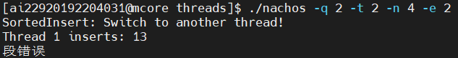
（PS：2个线程，每个线程插入4个节点，插入后再删除。）
（1）造成错误的代码：
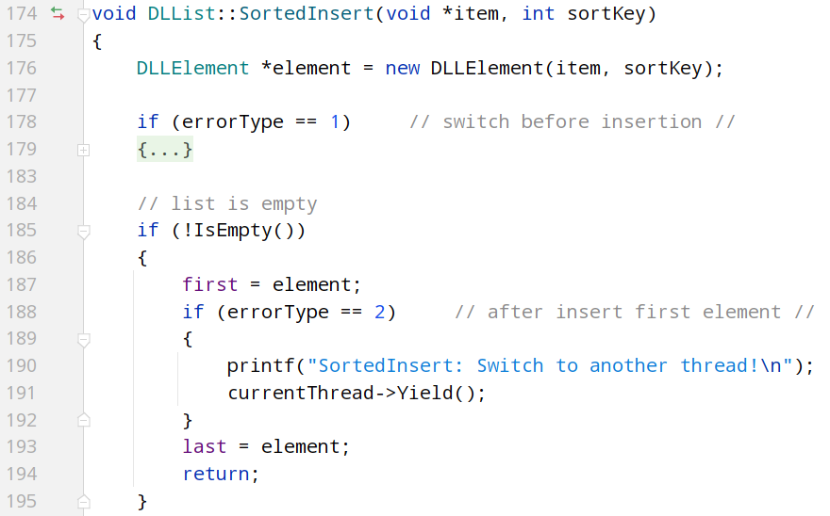
（2）原因分析：在线程0中插入结点时，因为链表为空，建立新结点，first=element，但last还没有定义，此时切换线程。在线程1中插入结点，链表非空，缺少last产生错误。

2、使用由睡眠/唤醒原语实现的锁和条件变量时，不报错。
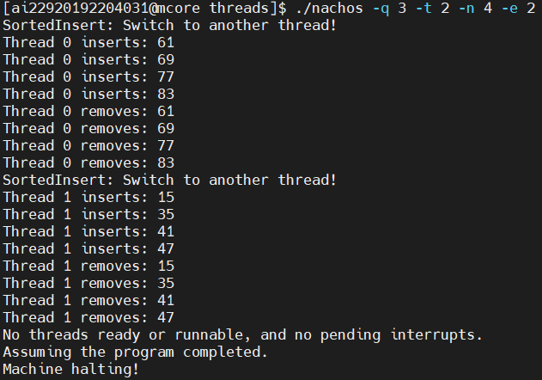

3、使用由信号量实现的锁和条件变量时，不报错。
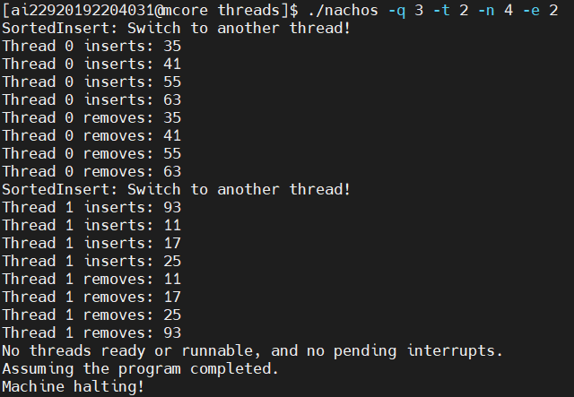

4、对Table进行测试，设定10个线程。
（1）设定2个为表分配数据的线程，2个随机检索表的线程，2个随机释放表数据的线程，次数均为2次。表的最大容量为3。可以看到，线程1第二次插入数据时，已经没有空间，故插入失败。
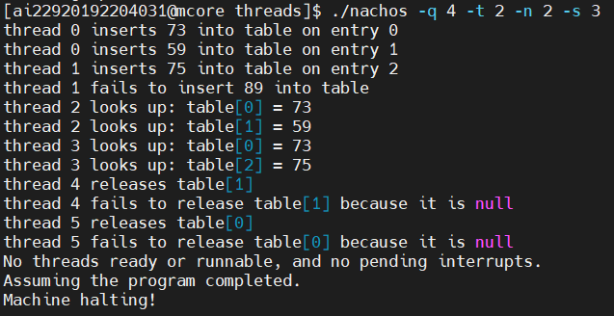
（2）在插入数据时，如果已经没有空间，则切换线程，这是不使用锁和条件变量的结果：
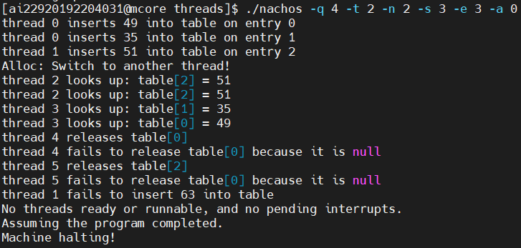
（3）使用锁和条件变量：
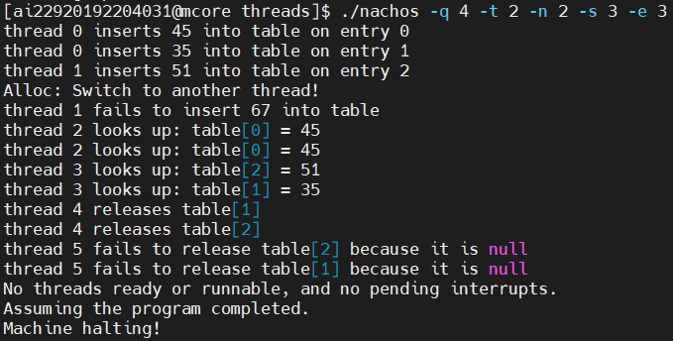

5、对BoundedBuffer类进行测试。
（1）设定2个生产者，2个消费者（线程0、1为生产者，线程2、3为消费者），每个线程读或写的次数为1，有界缓冲区的最大容量为3，生产者每次写4个数据，消费者每次读4个数据。可以看到，当有界缓冲区满时，生产者会进入休眠状态，直至消费者读了一些数据。
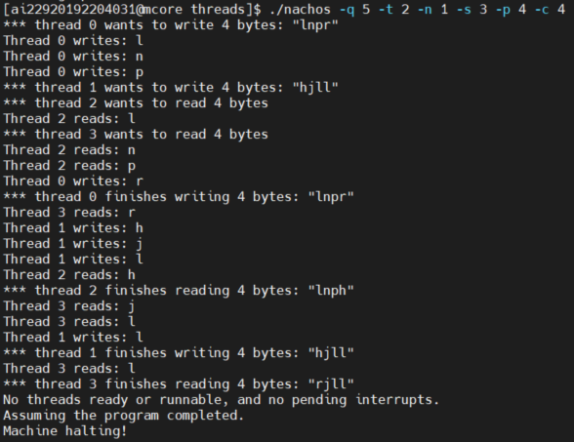
（2）在生产者写入数据后切换线程，这是不使用锁和条件变量的结果，消费者在缓冲区为空时会继续读数据而不进入休眠状态，从而造成读空，这是不允许的：
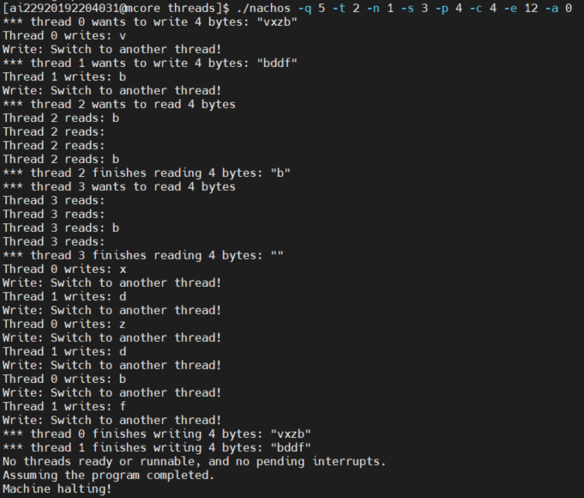
（3）使用锁和条件变量后，在缓冲区空时，消费者会进入休眠状态，直至生产者写入一些数据，从而不会读空：
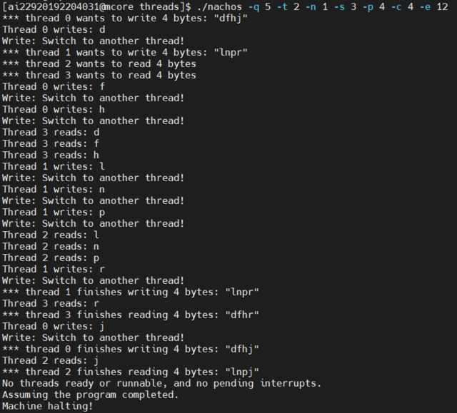

五、实验总结
1、用锁机制和条件变量可以有效地解决并发问题，不管是使用睡眠/唤醒原语还是信号量实现。
2、线程安全表Table存储由[0..size-1]范围内的整数索引的非类型化对象指针的集合，可以作为未来实验的内部操作系统表。当表满时，线程的插入操作会直接丢失。
3、线程安全的BoundedBuffer类可以创建有界缓冲区，生产者将数据放入缓冲区中，消费者从缓冲区中取数据。当缓冲区满溢时，继续插入会扩展缓冲区。使用锁和条件变量后，满溢时生产者会进入休眠状态，直至消费者读了一些数据。

六、实验心得
本次实验是上一次实验的延续，在找出并发性错误后思考如何解决这些错误，帮助我复习理论课中信号量等内容。测试环节出现了较多的问题，比如忘记更改Makefile文件导致编译错误等等，感谢其他同学的耐心帮我分析问题并解答。
编写代码的过程中我查阅了大量资料，大部分时间都用于分析代码理解代码，所以我应该加强自己的编程能力。

